3 December 2025

Dear families
I would like to express my thanks to every parent for your speedy response to today’s unforeseen closure. I appreciate it is very difficult for families to change their routine at short notice. The safety of our children is paramount, and I hope you will see why it was so important to gain permission from parents for students to leave the site. All our students were safely offsite by 11am.
The closure was due to an issue with our kitchen facilities, which meant we were unable to ensure we could safely provide meals for all our students.
The academy will be open as usual to all students on Thursday 4 December.
We will be able to offer a cold food option at lunchtimes only. If you would prefer, or if your child has specific dietary requirements, please send them with a packed lunch.
We look forward to seeing all students tomorrow.
Kind regards
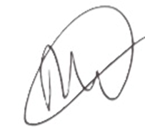
Richard Wilson
Academy Principal

